**CITY NURSERY AND PRIMARY SCHOOL.**

**END OF MARCH EXAMINATIONS 2024**

**P.7 INTEGRATED SCIENCE**

***Time Allowed: 2hours 15 Minutes***

***INDEX NO.***

|  |  |  |  |  |  |  |  |  |
| --- | --- | --- | --- | --- | --- | --- | --- | --- |
|  |  |  |  |  |  |  |  |  |

**CANDIDATE’S NAME: …………………………………………………....**

**SCHOOL NAME: ……………………..……………………………………………**

**DISTRICT NAME: ………………………………………………………. .**

|  |
| --- |
| **READ THE FOLLOWING INSTRUCTIONS CAREFULLY.**  **1** This paper has two sections**: A** and **B**.  **2** Section **A** has **40** questions (**40** Marks).  **3** Section **B** has **15** questions (**60** Marks).  **4** Attempt all questions in both sections. All answers to both sections A and B must be written in the spaces provided.  **5** All answers must be written in **blue** or **black** ball point pens or ink. Only diagrams and graph work must be done in pencil.  **6** Unnecessary alteration of work will lead to loss of marks.  **7** Any handwriting that cannot be easily read may lead to loss of marks.  **8** Do not fill anything in the boxes indicated: “**FOR EXAMINER’S USE ONLY**”. |

|  |  |  |
| --- | --- | --- |
| **FOR EXAMINERS’ USE** **ONLY.** | | |
| **Qn. No.** | **MARKS** | **INITIALS** |
| **1 - 10** |  |  |
| **11 – 20** |  |  |
| **21 – 30** |  |  |
| **31 – 40** |  |  |
| **41 – 43** |  |  |
| **44 – 46** |  |  |
| **47 – 49** |  |  |
| **50 - 52** |  |  |
| **53 - 55** |  |  |
| **TOTAL** |  |  |

***Turn Over***

**SECTION A (40 MARKS)**

1. Name the body sense organ for feeling.

**………………………………………………………………………………………………………………………………………………………………**

2. How do we call the process by which food is broken down into small soluble particles that can be absorbed by the body?

**………………………………………………………………………………………………………………………………………………………………**

3. Give any **one** way of conserving fossil fuels in the environment.

**………………………………………………………………………………………………………………………………………………………………**

4. How do we call the breathing organs of a spider?

**………………………………………………………………………………………………………………………………………………………………**

5. Mention any **one** example of a perennial crop.

**………………………………………………………………………………………………………………………………………………………………**

6. How are secateurs important to a crop farmer?

**………………………………………………………………………………………………………………………………………………………………**

7. Why is a stone regarded as an irregular object?

**………………………………………………………………………………………………………………………………………………………………**

8. What do you understand by the term **germination**?

**………………………………………………………………………………………………………………………………………………………………**

9. How does sound from a radio reach the ears of the listener?

**………………………………………………………………………………………………………………………………………………………………**

**Use the diagram below to answer questions 10 and 11.**

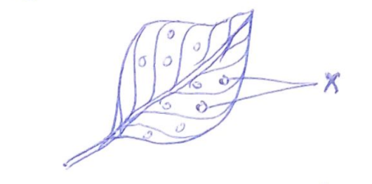

10. Name the structures marked X in the diagram above.

……………………………………………………………………………………………………………………………………………………………………

11. Name the human body organs that perform the same function like that of the structures mentioned above.

……………………………………………………………………………………………………………………………………………………………………

12. State any **one** difference between mass and weight.

……………………………………………………………………………………………………………………………………………………………………

13. Name the **longest** bone in the bone.

……………………………………………………………………………………………………………………………………………………………………

14. Give any **one** physical process involved in the water cycle.

……………………………………………………………………………………………………………………………………………………………………

15. Identify any **one** way of preventing cannibalism in a poultry house.

……………………………………………………………………………………………………………………………………………………………………

16. How is a duck billed platypus similar to a duck in terms of their reproduction.

……………………………………………………………………………………………………………………………………………………………………

17. **Covert 00C to 0F**

18. Mention any **one** natural source of light in the environment.

……………………………………………………………………………………………………………………………………………………………………

19. Write down any **one** way in which plants depend on people.

……………………………………………………………………………………………………………………………………………………………………

20. How is an eagle dangerous to a poultry farmer?

……………………………………………………………………………………………………………………………………………………………………

21. Identify any **one** example of a tick borne disease that affects cattle.

……………………………………………………………………………………………………………………………………………………………………

22. What type of reflection is illustrated in the diagram below?

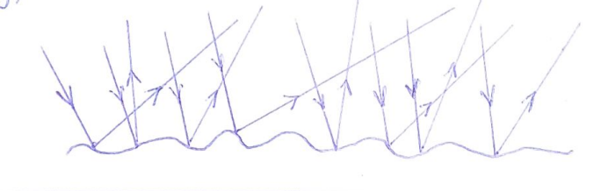

……………………………………………………………………………………………………………………………………………………………………

23. In one sentence explain the term **lever.**

……………………………………………………………………………………………………………………………………………………………………

……………………………………………………………………………………………………………………………………………………………………

24. Why do chameleons change their colors of appearance?

……………………………………………………………………………………………………………………………………………………………………

25. What term describes a **combination of gases**?

……………………………………………………………………………………………………………………………………………………………………

26. Why are handles of an iron box made of wood?

……………………………………………………………………………………………………………………………………………………………………

27. State any **one** factor considered when classifying animals in the ecosystem.

……………………………………………………………………………………………………………………………………………………………………

28. Briefly explain the term **Vasoconstriction** as used in excretory system.

……………………………………………………………………………………………………………………………………………………………………

……………………………………………………………………………………………………………………………………………………………………

29. Give any **one** cultural practice that promotes the spread of AIDS.

……………………………………………………………………………………………………………………………………………………………………

30. Which process is used to obtain water from ice?

……………………………………………………………………………………………………………………………………………………………………

31. Name the magnetic pole marked with letter **X** below.

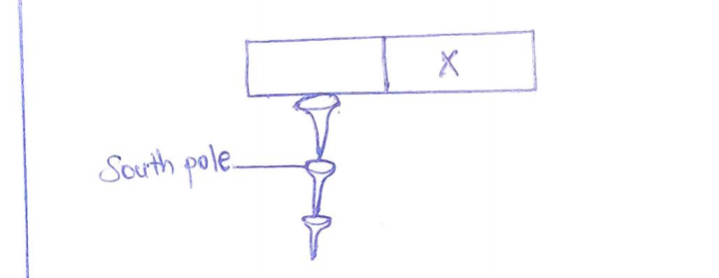

……………………………………………………………………………………………………………………………………………………………………

32. Why is water regarded as a renewable resource?

……………………………………………………………………………………………………………………………………………………………………

33. Why should health workers prescribe drugs?

……………………………………………………………………………………………………………………………………………………………………

34. Mention any **one** condition necessary for rusting to take place.

……………………………………………………………………………………………………………………………………………………………………

35. Why is **tepid sponging** an important first aid to a person with high fever?

……………………………………………………………………………………………………………………………………………………………………

36. Name the last type of teeth to grow in humans.

……………………………………………………………………………………………………………………………………………………………………

37. How does a crop farmer benefit from a nearby apiary?

……………………………………………………………………………………………………………………………………………………………………

38. Why are plants regarded as producers in the food chain?

……………………………………………………………………………………………………………………………………………………………………

39. Write down any **one** property of air.

……………………………………………………………………………………………………………………………………………………………………

40. Suggest any **one** example of water borne disease that affects the skeletal system.

……………………………………………………………………………………………………………………………………………………………………

**SECTION B (60 MARKS)**

**41a)** Explain the meaning of the term **rehydration.**

**…………………………………………………………………………………………………………………………………**

**b) G**ive any **one** way a dehydrated person can be rehydrated.

**……………………………………………………………………………………………………………………………………**

c) Write down two mineral salts that are regained in the body during rehydration.

**……………………………………………………………………………………………………………………………………**

42a) What are **renewable resources?**

**……………………………………………………………………………………………………………………………………**

b) Why is the sun referred to as a renewable resource?

**…………………………………………………………………………………………………………………………………**

c) How is the sun important to the following?

i) Rain cycle

**…………………………………………………………………………………………………………………………………**

ii) Plants

**…………………………………………………………………………………………………………………………………**

43**. The diagram below shows a body system. Study it carefully and use it to answer the questions that follow.**

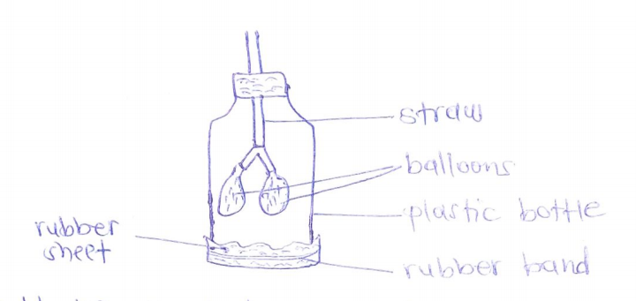

a) Identify the body system shown above?

**……………………………………………………………………………………………………………………………………**

b) Name the of the body system mentioned above represented by ;

i) Straw **…………………………………………………………………………………………………………………………………**

ii) Balloons **……………………………………………………………………………………………………………………………**

c) State what would happen to the rubber sheet if the balloons are filled with air?

**……………………………………………………………………………………………………………………………………**

44a) What do you understand by the term **puberty**?

**……………………………………………………………………………………………………………………………………**

b) Give any **two** physical sex changes that occur in both boys and girls.

i) **…………………………………………………………………………………………………………………………………**

ii) **………………………………………………………………………………………………………………………………**

c) Give any **one** way adolescents can manage their body changes.

**……………………………………………………………………………………………………………………………………**

45a) Write down **two** methods of heat transfer in matter.

i) **…………………………………………………………………………………………………………………………………**

ii) **………………………………………………………………………………………………………………………………**

b) Identify any **one** effect of heat gain on matter.

**……………………………………………………………………………………………………………………………………**

c) Give any **one** natural process that produce heat in the environment.

**……………………………………………………………………………………………………………………………………**

46a) What is a **joint**?

**……………………………………………………………………………………………………………………………………**

b) State any **one** substance that helps to reduce friction around a joint.

**……………………………………………………………………………………………………………………………………**

c) Write down any **two** examples of antagonistic muscles.

i) **…………………………………………………………………………………………………………………………………**

ii) **………………………………………………………………………………………………………………………………**

47**. Study the diagram of an electric bulb below and use it to answer the questions that follow.**

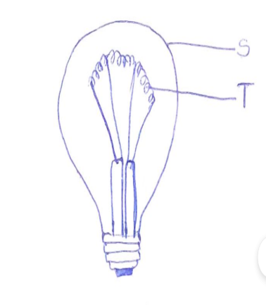

a) Name the part labeled with letter S.

**……………………………………………………………………………………………………………………………………**

b) Give a reason why part marked T is coiled?

**……………………………………………………………………………………………………………………………………**

c) Suggest any **one** reason why an electric bulb may fail to give out light.

**……………………………………………………………………………………………………………………………………**

d) Mention any **one** gas that is enclosed in part marked S.

**……………………………………………………………………………………………………………………………………**

48. Sylvia put one table spoonful of sugar into a glass of water and stirred it. The sugar then disappeared.

a) State what happened to the sugar?

**……………………………………………………………………………………………………………………………………**

b) What did the following act as in the above process?

i) Water **………………………………………………………………………………………………………………………**

ii) Sugar**………………………………………………………………………………………………………………………**

c) Write down the scientific name given to the final content in Sylvia’s glass.

**……………………………………………………………………………………………………………………………………**

49a) Define the term **balanced diet.**

**……………………………………………………………………………………………………………………………………**

b) Write down any **two** classes of food.

i) **…………………………………………………………………………………………………………………………………**

ii) **………………………………………………………………………………………………………………………………**

c) Suggest any **one** disease prevented through feeding on a well balanced diet.

**……………………………………………………………………………………………………………………………………**

50a) Where does absorption of digested food take place in the human alimentary canal?

**……………………………………………………………………………………………………………………………………**

b) Which type of digestion that takes place in the mouth by the action of the teeth?

**……………………………………………………………………………………………………………………………………**

c) Mention any **two** disorders of the digestive system.

i) **…………………………………………………………………………………………………………………………………**

ii) **………………………………………………………………………………………………………………………………**

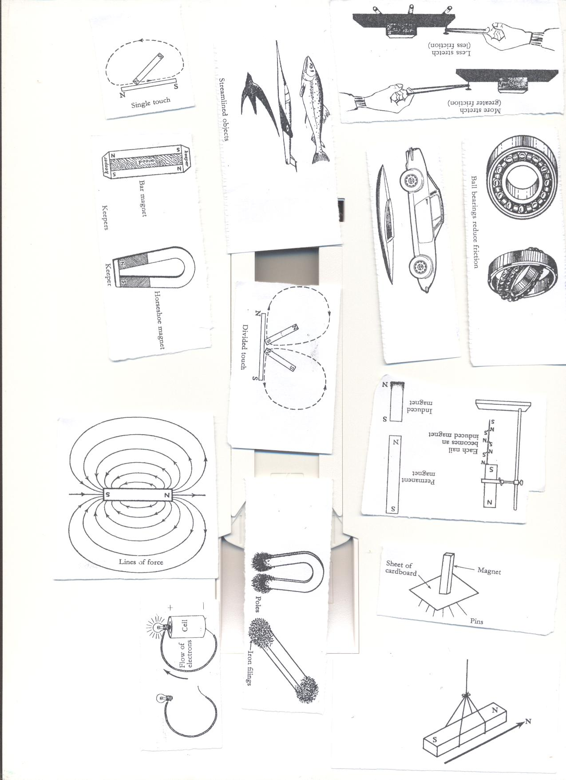51. **Below is a diagram showing a property of magnets. Study it carefully and answer the questions that follow**.

a) State the property of magnets shown in the diagram above.

**……………………………………………………………………………………………………………………………………**

**b)** Apart from the property of magnets written in (a) above, mention any **one** other property of magnets.

**……………………………………………………………………………………………………………………………………**

**c)** Mention any **one** example of a magnetic material.

**………………………………………………………………………………………………………………………………**

d) Suggest any **one** way of demagnetizing a magnet.

**……………………………………………………………………………………………………………………………………**

**52 a)** Name the **largest vein** in the body.

**……………………………………………………………………………………………………………………………………**

**a) G**ive any one functional difference between most veins and arteries in the human circulatory system.

**……………………………………………………………………………………………………………………………………**

**……………………………………………………………………………………………………………………………………**

**c)** Name the mosquito borne disease that attacks the red blood cells.

**…………………………………………………………………………………………………………………………………**

**d)** Suggest any **one** way of maintaining the proper functioning of the blood circulatory system.

**……………………………………………………………………………………………………………………………………**

**53. Match list A with list B correctly.**

**List A** **List B**

Lungs Bile pigments

Kidneys Sweat

Liver Carbon dioxide

Skin Urine

i) Lungs ………………………………………………………………………………………………………………………………………

ii) Kidneys……………………………………………………………………………………………………………………………………

iii) Liver ………………………………………………………………………………………………………………………………………

iv) Skin ………………………………………………………………………………………………………………………………………

54. **Use the diagram below and answer the questions below it.**

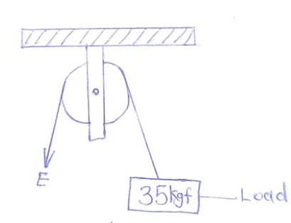

a) Name the type of pulley system drawn above.

**……………………………………………………………………………………………………………………………………**

b) Give any **one** use of the above pulley in our daily life.

**……………………………………………………………………………………………………………………………………**

c) Find out the amount of effort needed to overcome the load shown in the above pulley system.

55. **Complete the table below correctly.**

|  |  |  |  |
| --- | --- | --- | --- |
| **IMMUNISABLE**  **DISEASE** | **VACCINE**  **ADMINISTERED** | **MODE OF**  **ADMINISTRATION** | **BODY SITE** |
| i)……………………………….. | BCG Vaccine | Injection | Right Upper Arm |
| Diarrhea | ii)……………………….. | Orally | Mouth |
| Diphtheria | DPT Vaccine | Injection | iv)………………………….. |
| Polio | Polio vaccine | iii)…………………….. | Mouth |

**END.**